WGU GitLab Environment
- PERFORMANCE ASSESSMENTS
- WGU GitLab Environment
- Creating Branches for Development Work
WGU GitLab Environment
- Authenticate and sign in to the WGU GitLab Environment using your WGU single sign-on by selecting the Sign in button at https://gitlab.com/groups/wgu-gitlab-environment/-/saml/sso?token=Hzwm1Anx.
Note: Once you click the Sign in button, you will be directed to enter your WGU username and password as shown below.
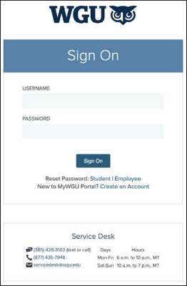
Figure 1. Prompt to authenticate by entering WGU username and password.

- After successfully signing in via single sign-on, you will be brought to the WGU GitLab namespace at https://gitlab.com/wgu-gitlab-environment.
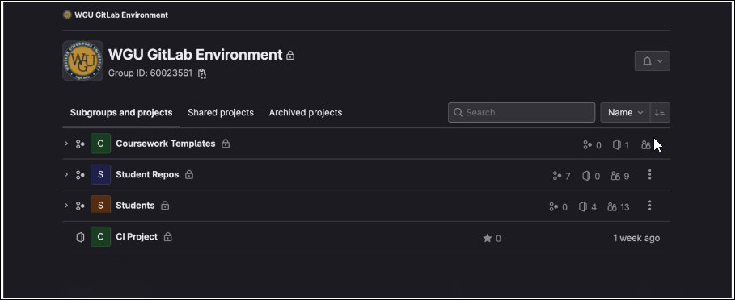Figure 2. WGU GitLab Environment page display after sign in.

- Select the Students subgroup, which holds projects that will initialize a repository for you. Then select the C971 course you are taking, which will bring you to the course project page.
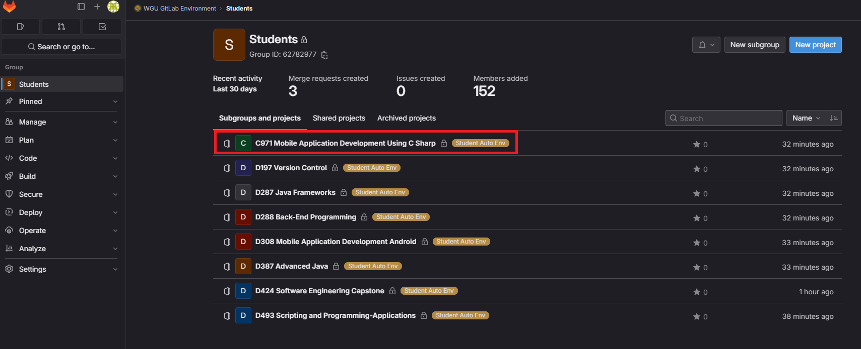 Figure 3. Students’ subgroup selection highlighted in the WGU GitLab Environment.

- On your course project page, select the Build tab found in the left banner and then select Pipelines.
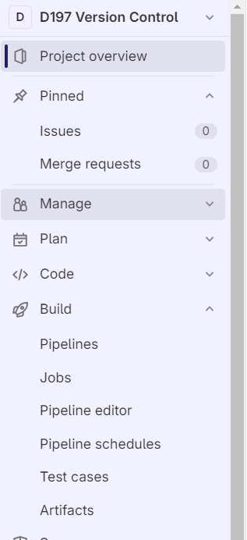
Figure 4. Build tab found in the left banner

- Once on the Pipelines page, select the Run pipeline button found in the upper-right corner as shown below.
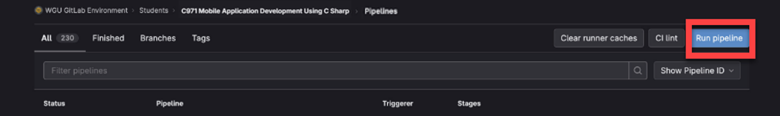Figure 5. Run pipeline selection highlighted in a WGU GitLab course project page.

- Ensure that students-run-this is selected from the Run for branch name or tag drop-down menu and select Run pipeline to continue. Note: You won't need to select any variables.
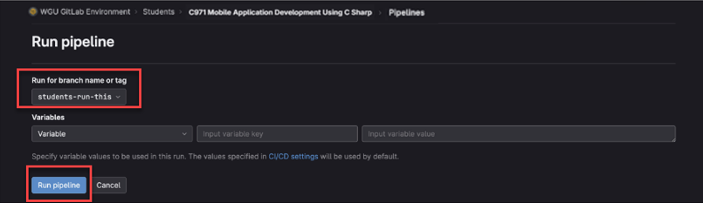 Figure 6. Run pipeline selections in a WGU GitLab course project.

- After the pipeline runs, your newly created subgroup and repository are located under the Student Repos subgroup (you can search for your repo by typing in your WGU username). Click on your repo and open it.
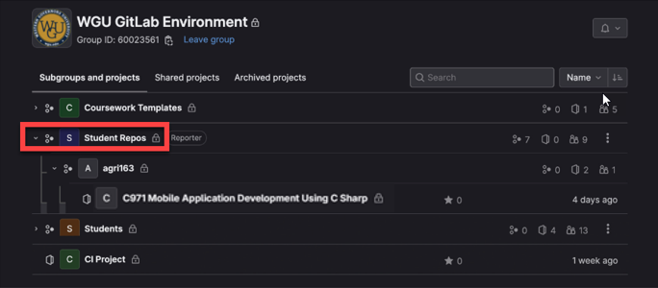
Figure 7. Student Repos subgroup selection highlighted in the WGU GitLab Environment.
- You should find in your subgroup a project titled “C971 Mobile Application Development Using C Sharp”. Click on it to open it.
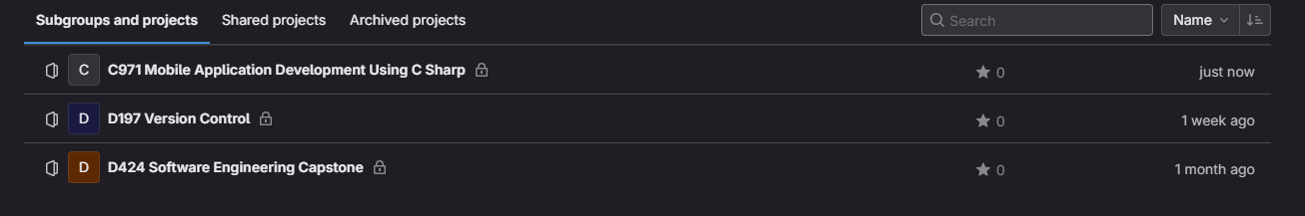
Figure 8. Subgroup C971.

- You should now see all the contents in your main branch of the project. Click on the plus sign (+) and select “New Branch” to create a new branch.
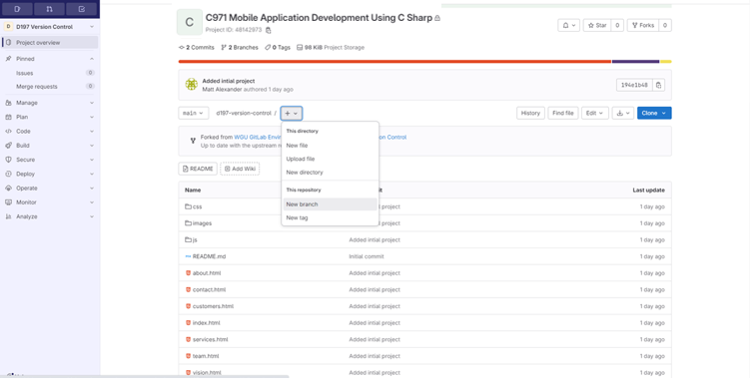
Figure 9. Finding New Branch.
- Call the new branch “Working”, leave “main” (by default chosen) in the Create from option and click the “Create branch” button.
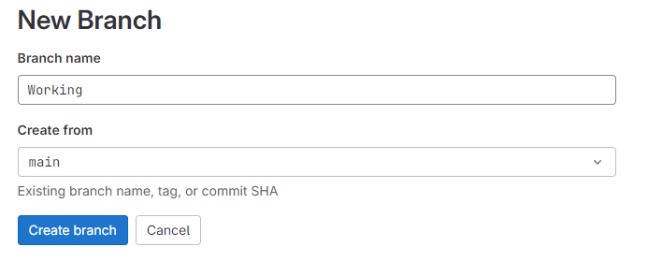
Figure 10. New Branch naming.

- You should now have two branches. You can view them by clicking on the drop-down list located on the main page of your project. Both branches are identical. You should not touch anything on the main branch throughout the entire project.
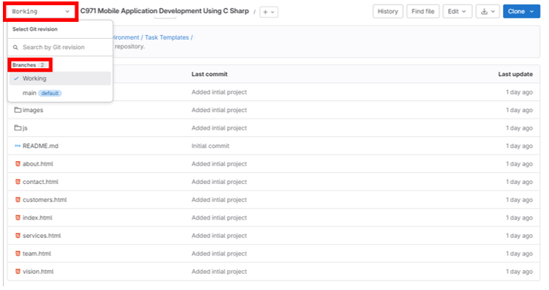
Figure 11. Two branches.

- To view your repository graph that shows you a visual history of your project. Select “Code” in the left-hand menu and then select “Repository graph”.
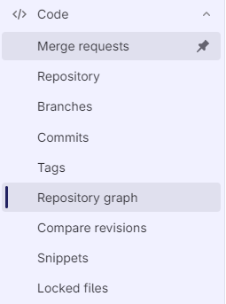
Figure 12. Viewing your repository graph.

To clone your project from the remote repo to Visual Studio 2022, follow the steps below.
  - Click the Clone button shown in the screenshot below, and then click the button under the Clone with HTTPS section as indicated.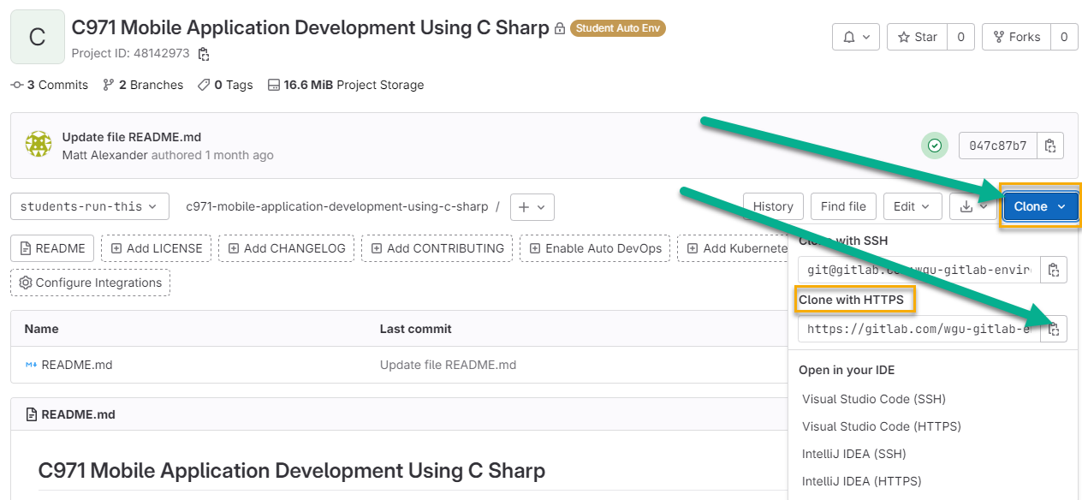
- Figure 1. Clone with HTTPS.

- Open the Visual Studio 2022 start page and select Clone a Repository.
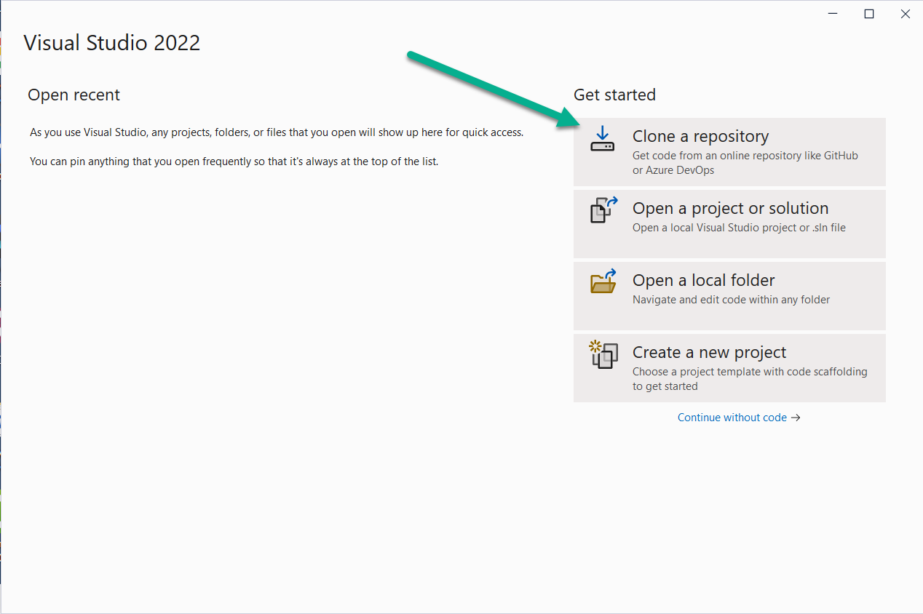
Figure 2. Clone a repository in Visual Studio 2022.

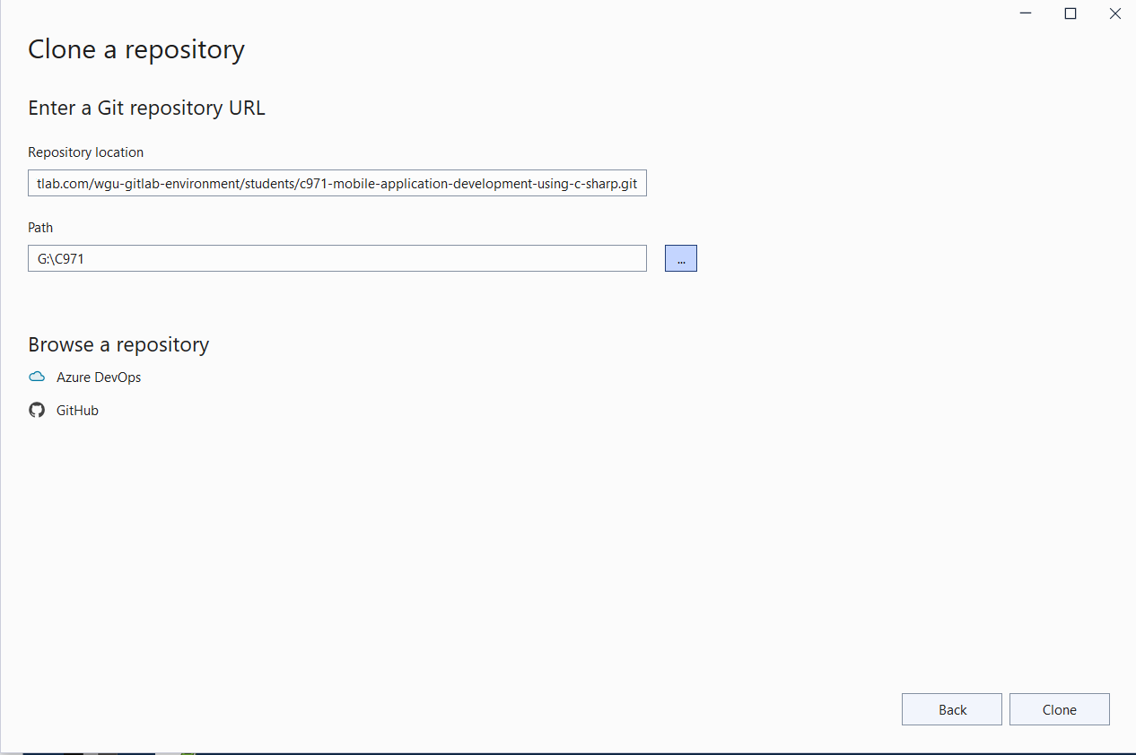
  - Enter your GitLab repo URL into the Repository location box and enter your local path in the Path box. Use a local path that is close to the root of your drive. For example, G:\C971 would be good. Then click Clone to continue. Your basic/starting project is now cloned to your local computer.

- Figure 3. Enter GitLab repo URL.

